Simon Light – PDP

# Qualifications

GCSE’s:

* A – Maths
* B – Double science, English Lit and Lang, Business, Drama, IT
* C – Spanish

A-levels (currently studying):

* Computer Science
* BTEC IT Level 3
* Maths
* Product Design

Extracurricular:

* Level 2 canoe and kayak
* 2 start award Cadets
* Green Card award – RCC

# Strengths and Weaknesses

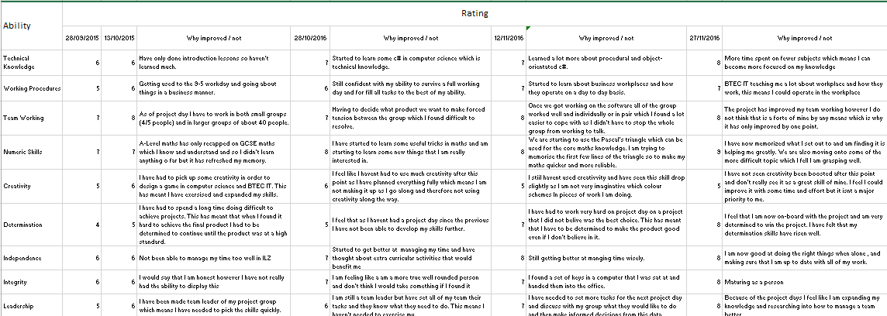

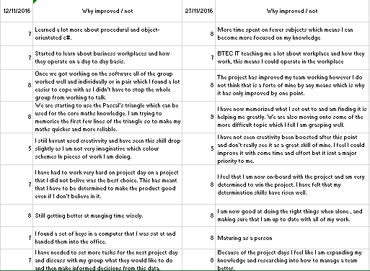

# Goals

## Short term

* Get a distinction Unit 1
* Revise for all of the upcoming progress tests
* Get fully trained at work
* Get my team selected for the PBA project

## Mid term

* Save enough to learn to drive
* Get a MOS
* Build a new Computer with a 3 screen set up

## Long term

* Pass A-Levels
* Seek an IT Apprenticeship
* Be self-reliant

# Progress

## 30/09/2015

* Have updated this report
* Started revising computer science
* Have finished my last trainee shift
* I pitched to the project leader of the PBA project

## 17/10/2015

* Achieved distinction in this assignment without any corrections.
* Created a plan on what I need to save money for so that I can manage it more effectively
* Fully revised for all progress tests

## 10/11/2015

* Started to move money into a savings account to achieve higher interest rates
* Completed all training for outlook MOS and am just waiting to take the test
* Have made a plan on my pc set up and have got three screens.
* Have been working hard on all of my A-level courses
* Looked into apprenticeships at GCHQ and other security companies.